◈
WebTrustEngine
R50 · v3.7 · Public

Executive Brief — The Decision Document
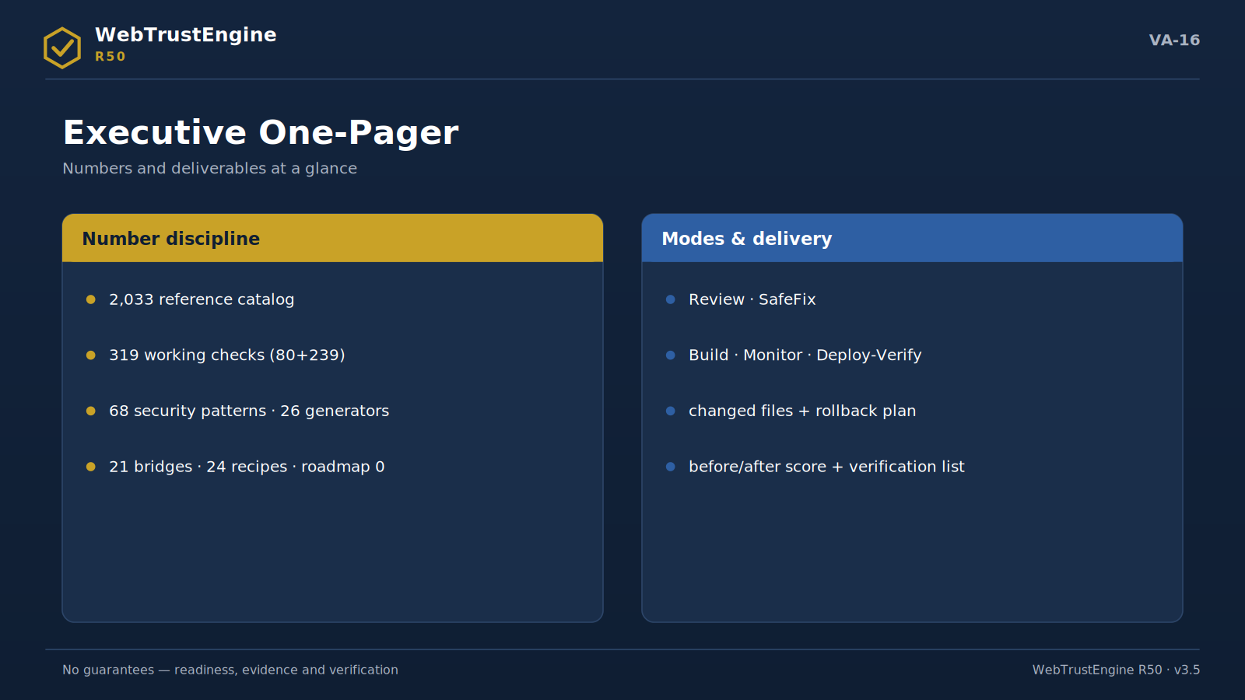
Figure VA-16 — The one-pager: number discipline on the left, modes and deliverables on the right.
The governance engine turning the web presence into a measurable corporate asset

July 2026

1. R50 at a Glance
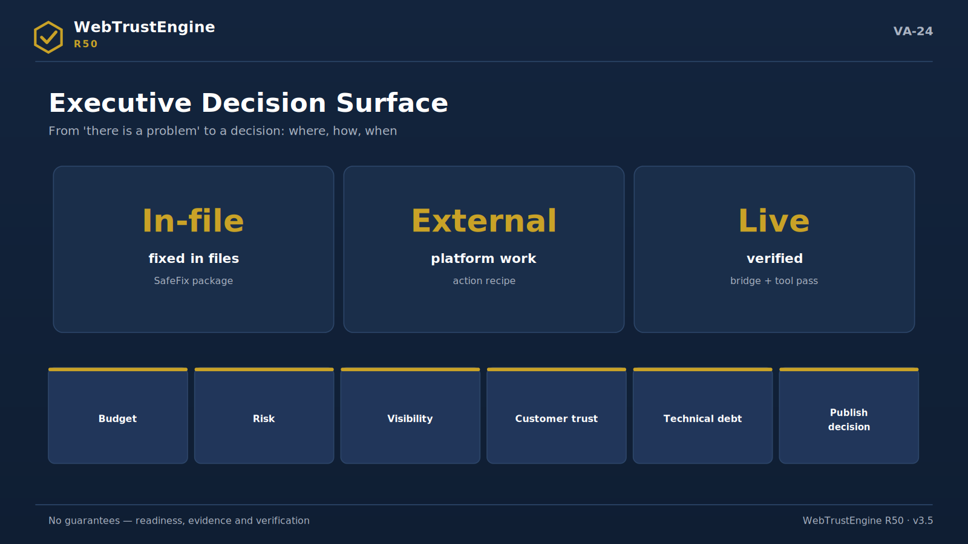
Figure VA-24 — The decision surface: where each finding is resolved, in executive language.
WebTrustEngine R50 turns the website from a marketing expense into a governed asset: every run produces a score, a changed-file list, a reversal plan and post-deployment verification evidence. The table below is the product's numeric backbone; no number is inflated.
Layer | Count | One line
Reference catalog | 2.033 | Signal map — not a check count
Implemented checks | 319 | Working detection counted from code
Security patterns | 68 | Static security patterns
SafeFix generators | 26 | Reversible fix generators
Runtime bridges | 21 | Independent tool bridges
External recipes | 24 | Panel/DNS instruction sets
ROADMAP | 0 | No unclassified items

2. The Problem: The Unmeasured Web
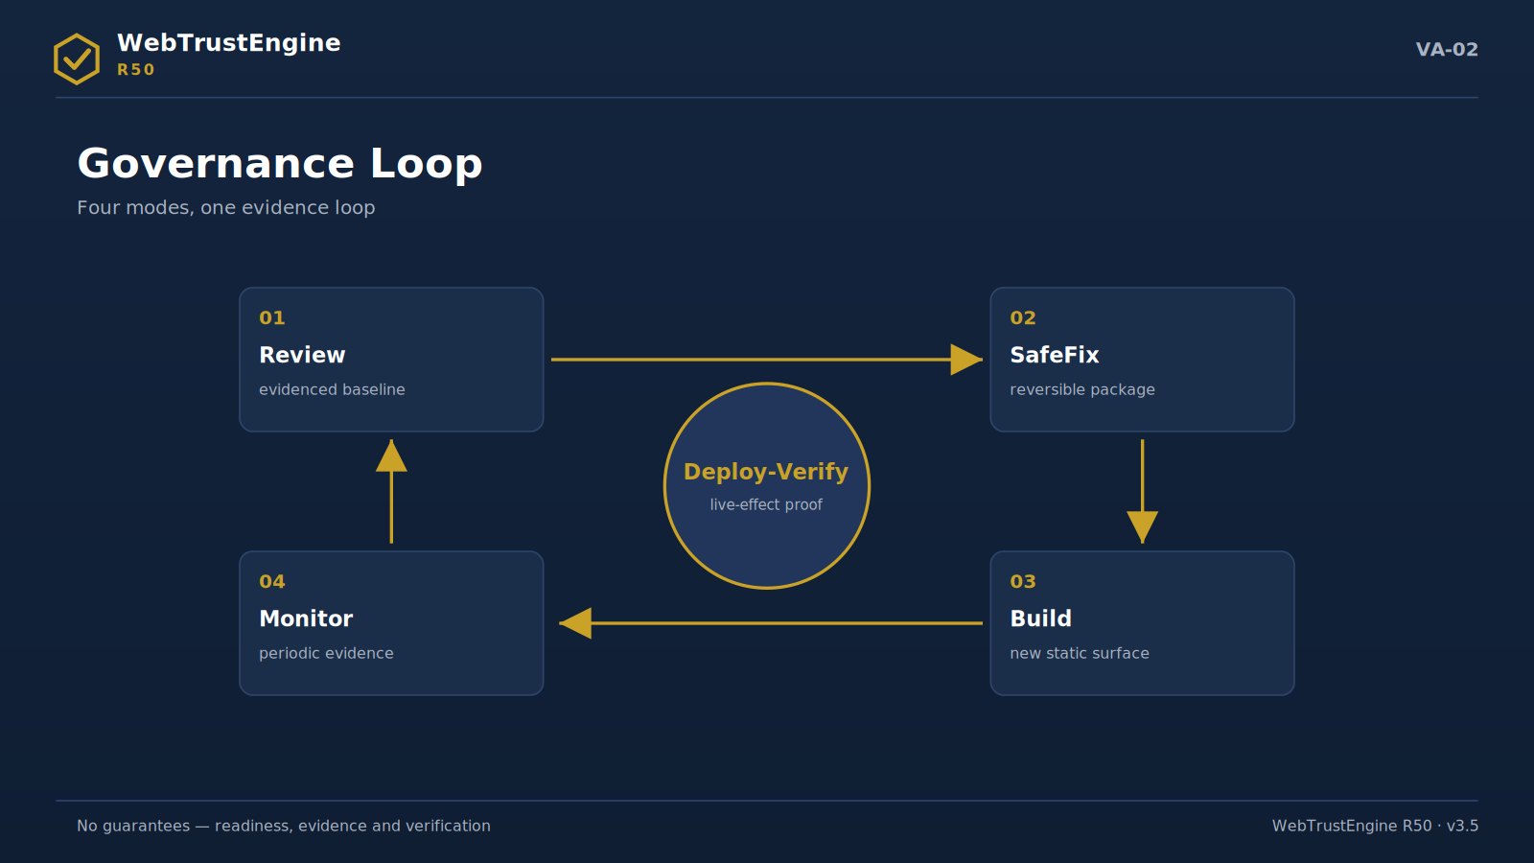
Figure VA-02 — The governance loop: Review, SafeFix, Build and Monitor around a Deploy-Verify core.
The corporate web today is the audit surface of dozens of automated readers: search engines, AI answer systems, security scanners, social-preview platforms. These readers look not at design but at headers, schemas, certificates and policies. In most organisations this surface has no owner: SEO with the agency, security with IT, accessibility with no one.
The result is familiar: five disconnected scores from five tools, no answer to 'what changed', fixes whose live effect is unknown. The executive wants to decide; what they hold is uninterpreted points. R50 reduces this scatter to one decision surface.
3. The Solution Architecture: Four Modes
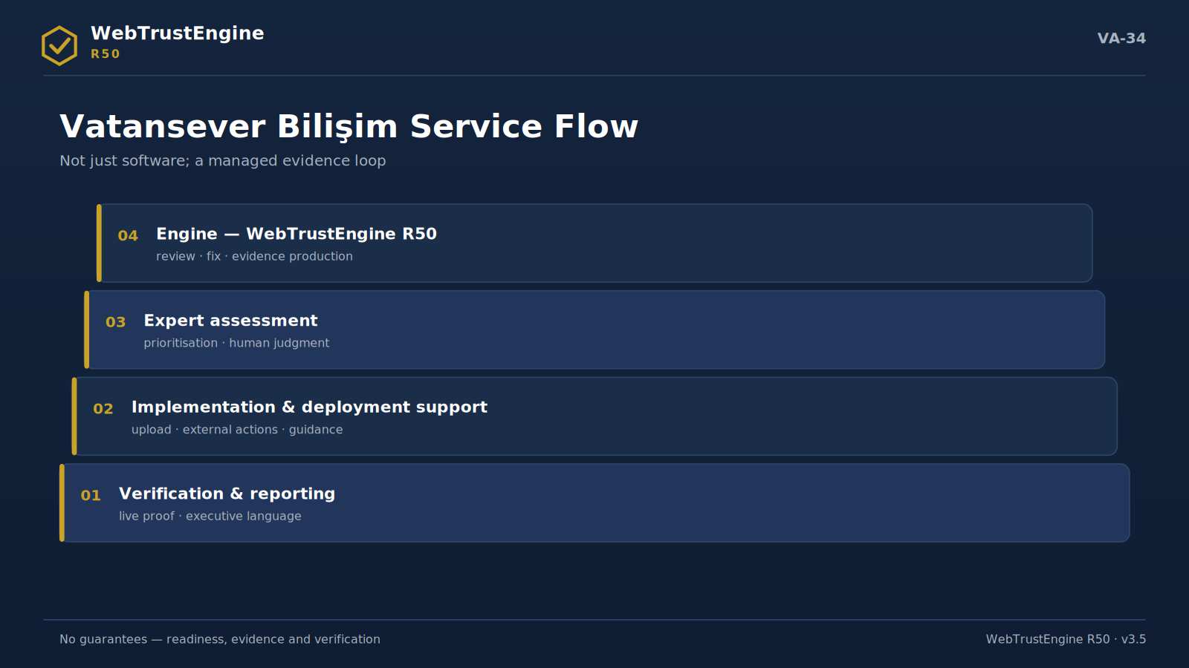
Figure VA-34 — The service flow: engine, expert, implementation support and reporting layers.
Review
An evidence baseline with zero file changes: score + findings + class distribution + suggested step.
SafeFix
A low-risk reversible fix package: fixed ZIP + changed files + rollback + before/after score.
Build
Schema-ready, claim-safe static production; publishing is always a human decision.
Monitor / Deploy-Verify
The periodic loop proving live effect after upload: baseline-diff + independent tool bridges.
4. Ten Domains — The Executive Read
Each domain's one-line meaning for the executive:
Domain | Executive meaning
Security Headers | Answers 'what does our site promise the browser'; a low score is invisible yet measurable corporate risk.
TLS / HTTPS Readiness | Browser 'not secure' warnings touch brand trust directly; this domain prevents them.
Technical SEO | The findability infrastructure; the precondition for content investment not being wasted.
Structured Data | The brand's identity card in the machine world; missing means reading as 'anonymous'.
Accessibility | Both inclusion and legal-risk territory; the readiness score makes both visible.
Performance Readiness | Speed is conversion's silent partner; readiness closes half of 'why are we slow live'.
AI / GEO / AEO | In the answer era visibility means appearing inside the answer; this domain builds that readiness.
Privacy / Cookie | Privacy is now reputation; ungovernable without visibility.
Code / Static Security | Surfaces 'are unknown risks in the repo'; the dashboard of silent risk.
Delivery / Deployment | The infrastructure of how the brand appears wherever it is shared.

5. The Evidence Package: A File Set, Not a Report
Every run's delivery is auditable: score tables, a file-level change list, the rollback manifest, external-action recipes, the QA report, the manifest and checksums. 'Trust us' becomes unnecessary; the files speak. For procurement and internal audit this is the cheapest insurance against vendor risk.
▸ before/after scores
▸ changed files + rollback
▸ external recipes
▸ runtime bridge results
▸ manifest + checksums
6. Number Discipline: 319 and 2,033
Numbers are the easiest thing to inflate in this market. R50's stance is clear: 2,033 is a reference catalog and never presented as 'automated checks'; the working check count is 319 and is counted from code; CLI, quality gate and registry agree. This discipline is not a marketing choice but the product's trust architecture — verifiability for investors and enterprise buyers.
Rule The sentence '2,033 checks' appears in no material.

7. The Security Position
R50 offers a static security review: secret leakage, exposed files, risky code patterns, server-side SAST classifications, OWASP mapping and header recipes. It is not a pentest and is never sold as one; active testing happens only with written authorization and a separate scope. This boundary is both legal safety and vendor credibility.
8. The AI-Era Position
In the answer-engine era, visibility means appearing inside the answer. R50 builds readability readiness via identity clarity, structured data, llms.txt and answer-ready FAQ. It gives no citation guarantee — no honest vendor can — but it measurably installs the signals that let AI systems read you correctly.
9. Boundaries — Explicitly
▸ No ranking/traffic/AI-citation guarantee
▸ No live 'production PASS'; evidence and readiness instead
▸ Field Core Web Vitals are not produced by the engine; verified via independent tools
▸ DNS/CDN/hosting work goes to the owner via recipes
▸ Legal-compliance judgments sit in the human layer
10. The First 90 Days
Period | Evidence
0-15 | The baseline report
15-30 | SafeFix + rollback + score delta
30-45 | The Deploy-Verify diff report
45-60 | Independent tool-bridge results
60-90 | External-action status + first Monitor

11. Five Decision Questions
Q: What are we buying?
A: Not a scan; a governance loop that produces evidence.
Q: How does our risk drop?
A: Silent risks surface, fixes apply reversibly, effect verifies live.
Q: Does it clash with our team/agency?
A: No; it becomes the evidence layer for acceptance and reporting.
Q: How is scale set?
A: Via four scope components: size, languages, modes, monitoring cadence.
Q: What is the first step?
A: A Review: the decision surface on the table within the week.
12. Next Step
Schedule a Review with your current site ZIP; the first decision meeting arrives with the baseline report and a suggested scope. This document contains no pricing; scope components are settled in conversation.
13. Domain Cards: The Risk Signal, The Evidence Name
In the board room every domain must be defensible in one line:
Security Headers — risk: browser warning / reputation; evidence: the live header report
TLS/HTTPS — risk: the 'not secure' label; evidence: the SSL Labs confirmation
Technical SEO — risk: invisible content investment; evidence: the coverage+meta table
Structured Data — risk: an anonymous brand; evidence: the schema validation output
Accessibility — risk: excluded users + legal risk; evidence: the static set + manual queue
Performance — risk: silent conversion loss; evidence: the readiness delta + PageSpeed
AI/GEO/AEO — risk: being outside the answer; evidence: the signal audit list
Privacy/Cookie — risk: reputation + regulatory risk; evidence: the tracker visibility report
Code/Static Security — risk: silent repo risk; evidence: the pattern report + OWASP map
Delivery — risk: broken look when shared; evidence: the preview + icon confirmation
14. Value for Four Personas
CEO
The web asset now enters the management report: a score curve, closed risks, verified change.
CFO
Spend maps to evidence: which file, which improvement, which verification. Vendor invoices leave the vague 'improvements' line.
CMO
Campaign pages launch with evidence: speed readiness, preview integrity, tracking hygiene in one run.
CTO
Boundaries are written in engineering language: the SAST/DAST split, idempotent fixes, rollback, the bridge contract. No surprises.
15. The Investor and Audit Perspective
The web section of a due-diligence file is usually screenshots; with R50 the same section is an evidence package: versioned scores, signed checksums, a change history. 'The web asset is governed' stops being a claim and becomes an annex.
For internal audit the value is the same: file truth instead of vendor assertion; continuous cheap hygiene instead of an annual check.
16. The Comparison Frame: Discipline, Not Features
Feature lists mislead in vendor comparison; the six discipline questions below differentiate:
Discipline | R50 answer
Number proof | code-derived count + registry equality
Change proof | file-level list + rollback
Live verification | bridges + independent tools
Boundary statement | SAST/DAST + manual queue in writing
Integrity | manifest + SHA-256
Language discipline | the claim-safety matrix

17. Executive FAQ — Eight Short Answers
Q: Will our site break?
A: No; changes on a working copy, rollback one step.
Q: How fast do we see results?
A: Baseline in week one; four evidence files by day 90.
Q: What does our agency do?
A: The same work; acceptance now runs on evidence.
Q: Does it replace a pentest?
A: No; it complements. Active testing is separate, authorized work.
Q: Does it guarantee ranking?
A: No; it delivers base and readability readiness.
Q: AI visibility?
A: Signals are installed; citations are not promised.
Q: Who reads the report?
A: An executive page + technical annex: both in one package.
Q: What is the first cost item?
A: A scoping talk + Review; figures are not in this document.
18. Scope Components — Summary
Component | What it scales
Site size | Review time + finding volume
Languages | consistency auditing
Mode combination | engagement depth
Monitoring cadence | the Monitor rhythm

19. The Evidence Package — File Summary
▸ Score report (10 domains, before/after)
▸ Changed files + rollback manifest
▸ External-action recipes
▸ Runtime bridge result bindings
▸ QA + manifest + SHA-256
20. The Decision Checklist
▸ Was a baseline requested?
▸ Was scope discussed via four components?
▸ Is the SafeFix approver named?
▸ Is the Deploy-Verify date set?
▸ Is the evidence archive chosen?
▸ Is the 90-day measurement plan signed?
21. Ten Domains — Mini Cases (Representative)
A three-sentence representative case per domain: problem → run → outcome. Cases are model-type; no client data.
Security Headers: A corporate site at 3/9 header coverage. The SafeFix recipe + single-CSP rule applied. The live verification round confirmed 9/9; the double-policy risk closed in the report.
TLS/HTTPS: 14 http:// resources on inner pages. Line-level flags + the redirect recipe issued. The SSL Labs pass returned clean post-deploy.
Technical SEO: Meta coverage 61%, 12 canonicals missing. SafeFix completion + sitemap refresh ran. The coverage-error curve in Search Console turned down.
Structured Data: Schema on the homepage only, 23 required-field errors. Baseline blocks + conditional rules produced. Rich Results tested clean on representative pages.
Accessibility: Alt coverage 64%, 9 unlabeled fields. The static set fixed; contrast items queued for manual review. The reviewer pass closed in a day.
Performance: 7 render-blocking scripts, 31 dimensionless images. Defer + dimensions/lazy + the cache recipe applied. The PageSpeed lab pass confirmed the readiness delta.
AI/GEO/AEO: No llms.txt, scattered identity signals. The file + sameAs chain + answer-ready FAQ installed. The signal audit list went fully green.
Privacy/Cookie: Pre-consent tracking markers + flagless cookies. The visibility report + flag recipe produced; policy links added. Legal sign-off completed in the manual layer.
Code/Static Security: 2 hardcoded keys, 5 exposed files in the repo. A masked finding report + removal recipe issued. The re-run showed zero; the OWASP map archived.
Delivery: A 3-piece icon set, OG at 40%. The 10-piece set + full card fields produced. Post debugger-refresh, the shared look confirmed.
22. The Annual Governance Calendar
The ninety-day loop scales across the year; a representative quarterly view:
Quarter | Focus | Evidence
Q1 | Baseline + first SafeFix + live verification | 4 core files
Q2 | External actions + deepening AI signals | the recipe closure report
Q3 | Content/schema expansion + the Monitor rhythm | the periodic diff series
Q4 | Annual comparison + next-year scope | the annual evidence digest

23. Risks and Mitigations
Risk | Mitigation
Wrong expectation (guarantee perception) | The claim-safety matrix in every material; boundaries in writing
Scope creep | Four-component scope; changes only via written approval
Cache illusion ('nothing improved') | The Deploy-Verify procedure; purge is mandatory
Role gap (who owns DNS?) | The role table as a contract annex
Number mis-quotation | The number ledger + the single true table
Evidence archive loss | Archive location set on day one; verified via checksums

24. The Executive Mini-Glossary
▸ Baseline — The first evidence snapshot; zero point of all comparisons.
▸ SafeFix — The reversible fix package.
▸ Rollback — The one-step reversal plan.
▸ Deploy-Verify — The live-effect evidence pass.
▸ Bridge — The measurement link to an independent tool.
▸ Recipe — Step-by-step instructions for panel/DNS work.
▸ Manuel kuyruk — Items awaiting human approval.
▸ Evidence package — The score+files+manifest+checksums set.
▸ Scope component — Size/languages/modes/monitoring cadence.
▸ Claim-safety — The rule of promising nothing unverifiable.
▸ Internal score — The engine's readiness measure; not a tool grade.
▸ Diff raporu — The expected↔live difference table.
25. The Pre-Publish Approval Flow
Moving a SafeFix package live follows a six-step approval flow; each step has an owner and an output:
1. Scope approval — owner: Decision owner; output: the approved SafeFix scope list
2. Package review — owner: Technical team; output: a walkthrough of the changed-file list
3. Rollback drill — owner: Technical team; output: a five-minute reversal test record
4. Upload window — owner: Owner + expert; output: date/time + the purge plan
5. Live verification — owner: Expert; output: the Deploy-Verify diff report
6. Closure — owner: Decision owner; output: the evidence package signed into the archive
The flow's value is not speed but traceability: six months later, 'who approved what, on which evidence' is answered by the file.
26. Five Sentences Ready for the Annual Report
Five sentences backed by the evidence package and passed through the claim-safety filter; portable verbatim into the annual report or a management deck:
▸ Our web asset was measured all year under the 10-domain readiness model; every change is recorded at file level.
▸ All applied improvements were made via reversible packages, with rollback plans archived.
▸ Post-deployment effects were verified with independent tools and diff reports retained.
▸ Security review ran in static scope; items requiring active testing were separated for an authorized engagement.
▸ Domain and infrastructure actions were closed via the recipe-verification chain; open items are tracked with owners.
27. The Public Kit Map
This brief is the entrance to a wider public library; which question is answered where:
Question | Document
What does the product do in depth? | The Capability Guide (46 pp, 39 sections)
Technical boundaries and schemas? | The Technical Trust Note (31 sections)
Short answers? | The Public FAQ (100+ questions)
Visual storytelling? | The 32-visual + 24-banner kit
Website copy? | Guide §21 + the site_ready package
Accounting for the numbers? | The Number Ledger (Guide App. 24)

The entire kit is price-free and shareable; every file carries the same number contract and claim-safe language.
28. The Monthly Status Report Template (Copy-Ready)
A fill-in skeleton for the monthly web-governance report to management; every line points at an evidence file:
Period / Scope:
Month + scope components (size/languages/modes/monitoring).
Skor durumu:
Current internal scores across 10 domains + delta vs last month (source: the score report).
Work performed:
SafeFix runs, changed-file count, rollback archive path (source: the FIX/ROLLBACK manifests).
Live verification:
Deploy-Verify pass date + diff-table summary (source: the diff report).
External actions:
Closed this month + open items with owners (source: the recipe closure list).
Manuel kuyruk:
Items awaiting human approval + the oldest item's age.
Riskler / kararlar:
New risks, decisions requested, next month's single priority.
Evidence appendix:
Archive paths + checksum lines for every file named in this report.
The template's discipline is simple: no sentence enters without evidence; every sentence that enters binds to a file path.

