WebTrustEngine R50
One-Page Overview
Review. Safe-fix. Prepare to publish. Verify live.
What is it?
An evidence-first web governance engine that reviews your corporate website across security headers, technical SEO, structured data, accessibility, performance readiness, AI/GEO/AEO readability, privacy and deployment hygiene; applies low-risk fixes safely; and gives a clear plan to verify the effect live. It delivers an evidence package, not just a score.
R50 — number discipline
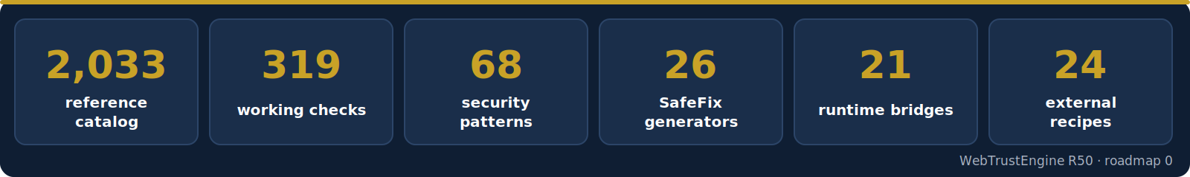
Figure — the R50 number contract: 2,033 is a reference catalog, not automated checks; working checks are 319.
Four modes
▸ Review — evidenced baseline; changes no files
▸ SafeFix — low-risk, reversible fixes
▸ Build — new static surfaces; publishing is separate
▸ Monitor / Deploy-Verify — post-deployment evidence
What you receive
▸ A 10-domain readiness score (before/after)
▸ Changed-file list + rollback plan
▸ External-action recipes + live verification checklist
Boundary
Ranking, traffic or AI citation are not guaranteed; evidence, readiness and verifiability are. The security review is static in scope; active penetration testing requires separate authorization and scope.
Şenol Vatansever · Vatansever Bilişim

